6COSC006W - Final Year Project Report

Contactless Voucher

Shouyi Cui (w1618594)

**Supervisor:** Barbara Villarini

BEng (Hons) in Software Engineering

School of Computing & Engineering

University of Westminster

Date: 13th July 2020

# Declaration

# Abstract

# Acknowledgements

# Table of Contents

# List of Figures

# List of tables

# Abbreviations

# Introduction

This chapter aims to give an overview of the context of this project, the problem the project is trying to resolve and the objectives.

## Problem Statement

Nowadays there are many ways a retailer can reward their most loyal customers. There are loyalty schemes almost for everything, from the coffee shops to flights. The more money you spend with a company, the more likely they are going to offer you special discounts because it is easier and more convenient for the business (Jovancic, 2019).

The current most common type of loyalty schemes available in restaurants such as Starbucks, Caffè Nero and Costa Coffee require the customer to register online on their service and then download a mobile application (DevTeam.Space, 2020). Sometimes it is the cashier that enables the digital stamp or other times it is the record of the purchase in the customer account. Other smaller food restaurants usually have a classic paper card where the cashier can make a stamp on it. The cards are usually made with empty icons that can be filled with the stamp to represent the accumulation of loyalty points.

Image sources:  https://www.tradeprint.co.uk/dam/jcr:a3f81a33-30e6-43c7-a798-6a9fdbf89a9b/comp_loyaltycard_170620_0187.jpg

https://www.thesun.co.uk/wp-content/uploads/2017/04/nero1.png



Figure . Paper loyalty card and loyalty Mobile App

In the example above (Figure 1.) on the left there is an example of a paper loyalty card and on the right a mobile loyalty app. The concept is similar but the way it works is completely different because the former is physical and the latter one is digital.

This purpose of this is to enable something in between the two existing solutions by using the NFC (Near Field Communication) technology, also known as contactless. This innovation is now available in most of the devices in the world and it is becoming more popular.

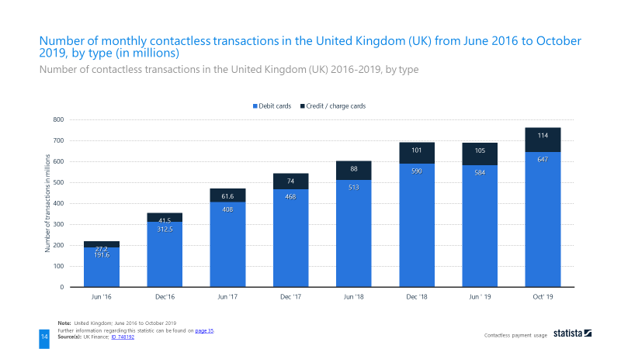

Figure . Monthly contactless transaction in the UK from June 2016 to October 2019

This technology is mostly used for payments with a small amount of money involved because it does not require any type of validation. The lack of validation makes the card more vulnerable to fraud (loveMoney, 2019), but that is a reasonable compromise for fast payments. Although it is also possible to set a limit for contactless card payment by the merchant or the card issuer.

Moreover, from an ethical and ecological perspective, this project has the potential to save the waste of plastic and paper by decreasing the demand of printed paper cards and plastic cards that “[…] have actually been the most requested gift in America” (Long, 2015).

## Aim and Objectives

The overall purpose is to create a Web App that uses the Web-NFC experimental feature on the Google Chrome browser on mobile (Bhaumik, et al., 2020) and allows both customer and retailer to manage their loyalty experience the way they want.

The main scope is to allow the customer an easy way to collect stamps or points without the need of a native mobile application. For the retailer, the advantage is a system where the loyalty experience is not restricted to a proof a purchase, but it could be a number of visits throughout a month or maybe an interaction with a new product in the store. With the use of the NFC tag, the retailer is also able to reuse the same piece of technology without investing into more complex machinery.

To achieve the desired goal, I will need to complete this list of objectives:

* Gain in-depth understanding on the NFC capabilities.
* Research NFC security known issues and always be aware on related news.
* Develop a prototype to use as demo for stakeholders.
* Constantly receive feedback from different sources to gain a wider perspective of the project.
* Adopt source code management systems to make sure there is trace of the progress made in case of work lost or not working as expected.
* Use a time tracking application for time management.
* Clear documentation of the project in terms of code and documents.
* Deployment of the project on a stable environment such a cloud service
* Implement an algorithm that compress the small amount of data
* Work with an external API that can send a digital voucher to the customer

Moreover, I would like to achieve these additional features (in descending order of importance):

1. Creation of own images and logos
2. Customisation of the interface per type of user
3. Gamification of the user experience

# Background

This section introduces the literature review of the project, a comparison of similar or relevant applications for the same customer reward. In addition, a discussion on the possible approaches for the intended solution is included.

## Literature Survey

The following sections of the literature review will cover different aspects of the NFC. Starting from the beginning of this technology and its original creator to the technical distinction of the modern world. The modern enhancement and what are the future capabilities are also discussed within the scope of the project.

### The history and physics behind

A Russian physicist and inventor called Léon Theremin (also known as Lev Sergeyevich Termen) in 1920 developed a musical instrument (later named after himself) that can produce sounds without being touched. The theremin core principles are heterodyning and capacitance. The former is the result of a combination or mixture of two frequencies (a principle used for FM radios) and the latter is the “ability of a circuit to collect and store energy in the form of an electrical charge” (Fluke Corporation, 2020).

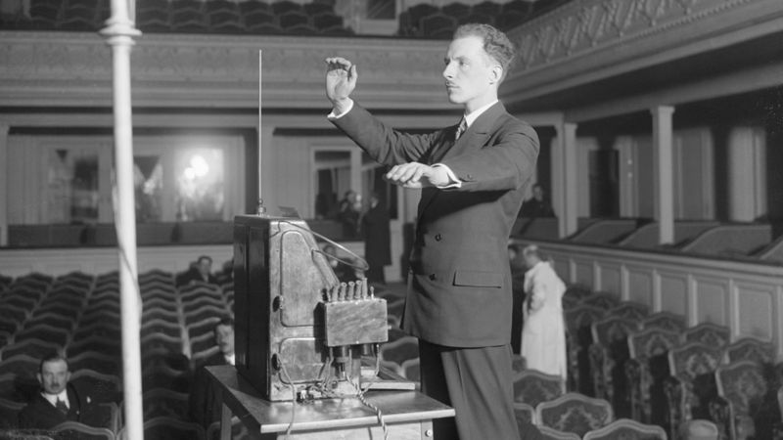

Figure . Léon Theremin playing his own invention

The electrical instrument has two metal antennas, one to control the pitch and the other to control the volume. When a hand goes near to an antenna, a natural capacitor is generated, and its capacitance change based upon the distance to the hand. The circuit of the instrument takes the capacitance and set a frequency for the pitch and the volume. Then an inductor inside the instrument creates the frequency to be combined with the previous one so it can result with an interference that is hearable by the human hear (Huth, 2018).

Later, in 1945 the World War II finally came to an end. On the 4th August in Moscow a group of boys from the Young Pioneer Organization of the Soviet Union went to the American embassy to give a present as a symbol of friendship between the two countries. Averell Harriman, the United States ambassador at that time, took the great wooden ornament (Figure 4) as an important gesture and hung it on the wall of his office. They probably have checked every side of it to make sure it was not going to cause any harm like a Trojan horse, but nobody found anything alarming (Harford, 2019).

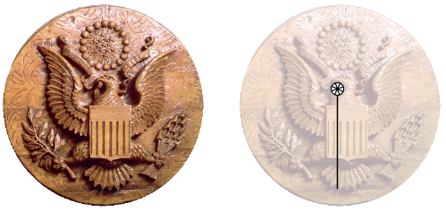

Figure . The present given to the US ambassador and the hidden device location

Eventually it was found out that the gift was an innovative creation from Theremin commissioned by his government to spy the conversation of the ambassador. It worked secretly for seven years until its discovery and gained the names “The Thing” and “The Great Seal Bug” (Harford, 2019).

The invention of Theremin consisted of a reverse concept of his musical instrument. He created a hidden circuit that had a capacitor that vibrated depending on the voice pattern. The capacitance would set the frequency representing the voice. An interference would be created when beaming a radio frequency signal to the object. This beaming would also power up and activate a response signal to broadcast out, so it could be received and analysed to get the information needed (Crypto Museum, 2015).

This can be conceived as the first example of the modern RFID (radio-frequency identification) technology because of the concept and physics involved.

In fact, the underlying principle of RFID consists of electromagnetic waves and mutual inductance. The latter is a physical principle that describes how the change of current in a coil can produce an electromotive force (EMF) in an inductively coupled coil.

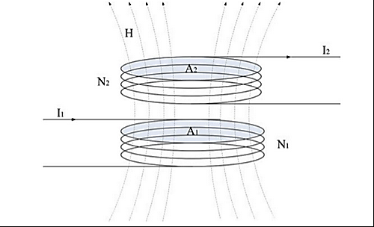

Figure . Inductive coupled coils

In the image above (Figure 5) we can consider $N_{1}$ to be an initiator that tries to engage to a target $N_{2}$. The mutual inductance between the two coils can be calculated by the following formula:

$$M_{12} = \frac{µ_{0}∙{H(I}_{1})∙N_{2}∙A_{2} }{I_{1}}$$

Being H the magnetic field strength, N the number of loops of the area A, and I the current that flows in the coil (Yang & Hancke, 2017).

### RFID (Radio-Frequency Identification)

RFID can be described as a form of wireless communication that uses the aforementioned electromagnetic principle (see 2.1.1) to uniquely identify an object (Rouse, 2007). It is purposely designed for identification because the RFID tags can hold only a small amount of data, usually around a thousand bytes or less (Igoe, et al., 2014).

There are two RFID types of communication mode: active and passive. But first of all, it is essential to define the two actors involved in the exchange: the target and the initiator. The initiator is the device that tries to read or write a tag, it generates the radio field and waits for responses from any target in the field. The target is usually the tag, that will respond with an UID (Unique Identifier Number) to the radio field (Igoe, et al., 2014). Therefore, the communication mode is considered as:

* *Active* when the target is powered independently (e.g. From a battery).
* *Passive* when the target has no power source. It usually gets the power from the radio field. Very similar to “The Great Seal Bug” (see 2.1.1).

At this point, it is worth mentioning there are various type of RFID protocol standards, usually developed by the ISO (International Standards Organisation) along with the major participants in the market. The different standards can change in terms of radio frequencies used (i.e. A lower frequency usually means a shorter read range), data format and data transfer rates (Lowry Solutions, 2014). These protocols are created for the purpose of having interoperable standards so that the technologies can work together and allow a competitive market from different industries (Igoe, et al., 2014).

### NFC (Near Field Communication)

NFC, similarly to the RFID, is also a wireless communication that works on the same physics principles mentioned before (see 2.1.1). It is designed upon the RFID protocols and it is generally possible to interact with the RFID tags (e.g. ISO-14443A tags are compatible with NFC). Its main role is to enable the target and the initiator to communicate by an exchange of meaningful data. This data can be either the capabilities of each other, records or even credentials.

It is important to note that NFC targets are not limited to tags, they can be also programmable devices like smartphones. There are two communication mode exactly like in the RFID: active and passive (see 2.1.2). Moreover, there are three operating modes:

* *Reader/Writer* when a device reads data from a target and/or writes to it.
* *Card emulators* when a device acts like a RFID tag in the electromagnetic field of another NFC or RFID device.
* *Peer-to-peer* when two devices exchange data to each other.

### Comparison between RFID and NFC

NFC can be considered as an enhanced version of RFID in the case where the initiator and target are in a short range. NFC is not designed to work the in long range so this limitation cannot be considered a real disadvantage, besides Wi-Fi and Bluetooth technologies are supposed to cover that gap.

Listed below are the common usage of the two technologies (Figure 6).

Image source: https://www.ecom-ex.com/fileadmin/_processed_/5/f/csm_17-02-07_RFID-NFC-final_153b8e3d75.jpg


Figure . RFID & NFC comparison

A big advantage of NFC is that it has a very low cost in comparison to the RFID, an NFC tag usually cost less than a pound (e.g. NTAG213, NTAG215, NTAG216). The long range advantage of RFID requires the target to be an active tag, and that is where the cost rise. Currently, every single RFID active tag can cost from £25 to £100 depending on the range required. The RFID reader is also very expensive costing from £150 to £1800 also depending on the range required (NextPoints, 2020). On the other hand, NFC readers can cost something around £40 but given that the number of smartphones with the NFC enabled are constantly increasing in numbers, maybe there is not even the need of an additional purchase.

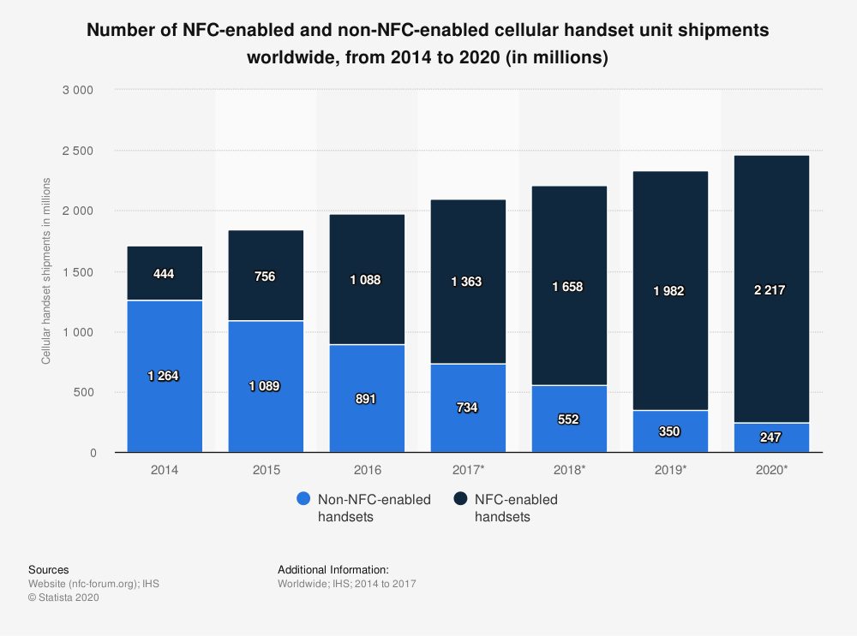

Figure . NFC enabled handsets from 2014 to 2020

In the figure shown above (Figure 7) it is possible to see the change over time of NFC enabled smartphones shipped in the world. Although this graph does not represent fully the numbers of all the smartphones in the market, it is fair to assume there is a similar trend because what changes is only the device delivery system.

In 2014 only the 25.99% handsets had NFC. Two years later, this feature increased in availability reaching 54.98%. Now in 2020, that percentage had rose to 89.98% and it is most likely to grow over time (Kenneth Research, 2020).

### NDEF (NFC Data Exchange Format)

NDEF is a data format operating across all NFC devices. A common NDEF message contains one or more NDEF records. Each of this record has its own UID, record type, length and payload of data (Igoe, et al., 2014).

A generic record is represented in the figure below (Figure 8).

Image source: 
https://w3c.github.io/web-nfc/#the-ndef-record-and-fields

Figure . NDEF record structure

* Bit 0-2 indicates the format of the type name.
* Bit 3 indicates the presence of an ID length field.
* Bit 4 indicates a short record.
* Bit 5 indicates whether the payload is chunked across multiple records.
* Bit 6 indicates whether this record is the last in the NDEF message.
* Bit 7 indicates whether this record is the first of the NDEF message.

This is the list of the NDEF record types:

1. **Empty NDEF** (TNF 0) as the name suggest it represent a record with no data and therefore Type Length field, ID Length field and Payload Length field must be 0 and the last three optional fields (Figure 8) must not be present.
2. **Well-known** (TNF 1) which is a set of sub record types standardised by the NFC forum such as text, URL, media and smart posters and handover options.
3. **MIME** (TNF 2) stores binary data with the associated MIME (Multipurpose Internet Mail Extensions) type.
4. **Absolute-URL** (TNF 3) contains the string of the full address that includes protocol and domain name.
5. **External** (TNF 4) is a Uniform Resource Name (URN) with the application data type (e.g. *urn:nfc:ext:domain.org:atype*).
6. **Unknown** (TNF 5) is for storing data that have incomprehensible data and are not associated with a MIME type. The application may assume the latter.
7. **Unchanged** (TNF 6) is a section of a chunked data set, so the payload is spread across multiple NDEF records.
8. **Reserved** (TNF 7) which means reserved by the NFC Forum for future use.

Image source:
https://w3c.github.io/web-nfc/#the-ndef-record-and-fields

Figure . Summary of possible Type Name Format (TNF)

### Web NFC

Web NFC is currently an experimental feature which overall goal is to give online sites the ability to read and write NFC tags in a secure and privacy preserving manner (Beaufort & Kenneth, 2020).

At the moment, this technology is limited to NDEF and is available as an original trial in Chrome v.81 until Chrome v.84 (Chrome Origin Trials, 2020) on Android OS smartphones.

The functionality can be enabled in the flags section (<chrome://flags/>) under the name “Experimental Web Platform features”. After the enablement, when surfing on the internet, if there is a website that wants to use NFC features for the first time, it will prompt a request to use it in the page. It is also going to prompt a message asking to turn on the NFC on the device in case it is off, while it is not going to show anything if the feature is not compatible with the device (e.g. iOS smartphones).

Image source:
https://storage.googleapis.com/support-forums-api/attachment/thread-13605645-4739816311749951377.jpg

Figure . Example of quick dropdown settings of an Android device with NFC

This new enhancement released on January 2020 gives the developers a lot of new potential in various use cases (Kostiainen, 2019).

The benefit of the NFC along with an ad hoc Web Application is that it can improve the UX (User Experience) by making the user interact with the surrounding environment (e.g. treasure hunts).

Hopefully, this Web API will be available in most of the modern mobile browser so that the developers can create more sophisticated solutions overtime. It has the potential of relieving the users from downloading ad hoc native applications on the mobile for simple use case scenarios.

## Review of Projects / Applications

In the following sections, the research on existing projects or applications relevant to the NFC and the intended project implementation will be presented.

### Google Pay

Google Pay has a mobile application that links to the user’s payment information to create an online payment system and digital wallet. It was developed by Google in 2015, known initially under the name “Google Wallet” and later merged with “Android Pay” (Nieva & Bennett, 2018). There are many features in the application such as image recognition, credit and debit card validation but those are not relevant to the scope of this project.

There are two aspects relevant in the e-wallet. First, the loyalty card system that asks the user to add the details of a physical card of the store by either camera scansion or entering manually. After the card details are successfully added in, the app generates a barcode representing the loyalty card. Secondly, the NFC payment system that uses the HCE (Host Card Emulation) to recreate a previously added credit card to make a payment at the POS (Point Of Sale). Note that the app does not send the exact card details but instead it uses a one-time security code that represents the user account information (Popper, 2015).

Advantages:

* Fast service.
* Secure and reliable.
* Automatic scansion of the card details by mobile camera.
* Unlimited payment amount, although some merchant applies the limit of £30 (Revolut, 2020).
* Available on Android devices running Lollipop 5.0 (released on June 2014) or higher.
* Does not need internet connection from the user point of view.

Disadvantages:

* Limited by the type of card issued by the bank.
* Restricted to Android OS and therefore not available on iOS devices. Considered as disadvantage because from a software development point of view it could mean two different implementations.
* Requires the store or retailer to have a specialised NFC reader that is not ideal in places like street food markets.

### Apple Pay (iPhone Wallet)

Apple Pay is also a payment system that has a mobile application as a digital wallet that can be used for store payments. Fundamentally is the same concept of Google Pay. It was initially created for online payments only and later developed the feature of HCE to work at the POS.

Advantages:

* Fast service.
* Secure and reliable.
* Automatic scansion of the card details by mobile camera.
* Available on the Apple devices from iPhone 6 (released on September 2014) onwards and Apple Watches. Some iPads can have the software application but they are unable to process the NFC in-store payment, hence it used for online payments only (Hill, 2020).
* Payment amount is usually unlimited but that depends on the country and the merchant (Apple, 2020)
* Does not need internet connection from the user point of view.

Disadvantages:

* Limited by the type of card issued by the bank.
* Restricted to iOS and therefore not available on Android OS devices. Considered as disadvantage because from a software development point of view it could mean two different implementations.
* Requires the store or retailer to have a specialised NFC reader that can be is not ideal in places like street food markets.

### Other digital wallets and payment solutions

There are many other digital wallets like Google Pay and Apple Pay currently having the NFC payment method or QR loyalty system. Therefore, those company solutions are just going to be briefly mentioned as a proof of the increased demand and popularity of this technology. It is also to prove the demand of loyalty schemes in the market.

#### Samsung Pay

Like Google Pay concepts, but with the difference that is enabled on Samsung devices only. It adds the ability of the MST (Magnetic Secure Transmission) that other e-wallets do not have (Whitwam, 2020). Released on August 2015 and available on most devices from Galaxy Note 5 onwards (Savvides & Orellana, 2019).

#### Microsoft Pay

Identical models as the previously mentioned e-wallets. The only difference is that is designed for Windows OS and the feature on mobiles has been withdrawn on 29th February 2019 (Thorp-Lancaster, 2019).

#### WeChat Pay (service inside WeChat)

It is similar to the previous payments systems but with the difference that the NFC capability is not popular in the stores because of the Chinese market. It is, in fact, used occasionally in the Chinese underground turnstiles (Borak, 2019). It is far more common the use of the QR (Quick Response) code as quick payment identification between users. The store does not need a POS anymore but instead it uses a smartphone or sometimes just a printed QR code. The scenario in a usual store transaction between customer and retailer are as follows:

1. Customer scans the retailer QR code.
2. Customer enters the money amount.
3. Customer validate transaction by either code or fingerprint
4. The app sends instantly the credit to the retailer.

Otherwise another option is:

1. Retailer scans customer QR code.
2. Retailer requests a payment to be sent via chat to the customer
3. Customer confirm transaction by code or fingerprint.

This solution is incorporated within the WeChat app that is available in all devices but Windows Phone (discontinued in 2016) and it also allows in-app store and web payments for loyalty schemes (Henriot, 2019). This app is popular among Chinese customers only (Borak, 2019), therefore out of the intended market of this project.

#### PayPal Wallet

Close to the aforementioned ideas, PayPal have developed this application to allow PayPal customers to pay using the QR code in the stores. This implementation released on May 2020 allows similar payment method as WeChat Pay, regarding the NFC aspect they rely on a Google Pay partnership (Smith, 2020).

#### Alipay Wallet

This company service needed to be commented due to the popularity and the high usage around the world. Alipay is considered to be the leading mobile payment platform but it does not have any NFC capability because solely based upon the QR code system (Heggestuen, 2014). It has a loyalty programme, but it works only with payments within the app (Basu, 2018).

#### Loopy Loyalty - PassKit

Loopy Loyalty is a web-based application part of the PassKit company solutions. It allows retailers to create a customised loyalty scheme by adding own brand images and colour palette.

The service offered works as loyalty card to be stored in Apple Wallet or Google Pay. An example of user journey case is:

1. The customer is registered in the loyalty scheme by email prior to the payment process.
2. The customer buys a product and therefore satisfies the stamp collection criteria (to be decided by the retailer).
3. The customer shows the QR code on its digital wallet that represents his details.
4. The retailer scans within the Loopy Loyalty Stamper mobile application the customer QR code.
5. The retailer has the option of choosing the number of stamps to give and redeem rewards if available (see Figure 11).
6. After the retailer has confirmed the options selected, the customer will have the loyalty card details updated.

Immagine screenshot source:
https://lh3.googleusercontent.com/CqPgAtSTKal-DProv1_xMobPhcA_jYlyAM4IZ4005p-bqhew2_v2EFLB6Lq1NOwpwA=w3068-h1444

Figure . Options for stamp record on Loopy Loyalty Stamper app

Although this system is very efficient, in practical terms, it is hard to use. The retailer would need to have his smartphone available all the time after a transaction is successfully completed. He would also need some time to interact on the smartphone to decide all the options for the customer. It increases the responsibility for the cashier and the time process for each customer.

### Embargo

Embargo is a mobile application where there are rewards scheme for people who often go to social places such as pubs and restaurants. The app is also available in various food market sites and it just requires the user to register into their service with no bank details.

The app gives rewards based upon the number of visits the customer accrue over time in the same place, like a classic loyalty scheme. A certain number of visits allow the customer to redeem rewards at the venue. Some special discounts are also included depending on the specific place.

As shown below (see Figure 12), the app has a very simple interface with few buttons and icons that result in a simple user experience which is very important for this type of service.

Image source: https://play.google.com/store/apps/details?id=com.embargoapp.app&hl=en_GB


Figure . Embargo App screenshot example from the Google Play Store

This case is different to the previous because there is not either NFC or QR code involved. Instead, there is beacon technology that requires the use of Bluetooth connection. To locate better the customer position in relation to the venue the app also requires GPS (Global Positioning System) to be enabled (Embargo Lifestyle Limited, 2020).

Advantages:

* No need of user personal details such as bank cards.
* It works similar to the NFC, but it uses Bluetooth, GPS and Wi-Fi.
* Complete user journey to bring more customer to the venues.
* There is an ability to automatically connect to the venue Wi-Fi network.

Disadvantages:

* The user must have Bluetooth, GPS and Wi-Fi enabled in order to work.
* Relies on a good internet connection environment which can be troublesome in a very crowded place.

#### Beacon Technology

The beacon technology is the closest alternative to the RFID and NFC use case scenarios. It uses the consolidated Bluetooth technology to send signals in the nearby in the form of UHF (Ultra High Frequency) radio waves around 2.45 GHz (Haines, 2020). Like the RFID active mode (see 2.1.2) it requires both ends to have their own power source but it can send more data, like in the NFC(see 2.1.3). It is designed to work in a short or medium range around 10 to 30 meters although it has the capability to reach 300 meters. The drawback is in terms of cost and availability because it is very hard to get one, and the cheapest transmitter, a keychain beacon, costs around £20. The price rises to around £40 for longer ranges (Ratna, 2020) which makes the solution more limited depending on the company’s budget. This was the major reason to not choose this technology for this project implementation.

### Jisp

Jisp is a company that provides a mobile application where you can buy products from selected retailers by using only the NFC feature in the smartphone. The user must register with a payment system like a bank card in the app to start purchasing products. A possible use case can be described as:

1. The customer is registered to the app and has the payment method set up.
2. The customer goes to the shop that have special tags for the products on the shelves.
3. Whenever the customer decides to pick a product, he scans the tag of the product to add it in the basket.
4. Once the customer has finished the choose the products, he goes to a checkout.
5. The checkout is another NFC specialised tag that completes the purchase by making the payment with the card details previously stored.

Advantages:

* Built around the NFC but it also can scan QR codes.
* User can use the app also to find information related to the product scanned.
* Can monitor user behaviour to customise what they may want.
* Gamification service to engage with the user such as quizzes.
* Does not require the user to register for using some app features such as scanning product details.

Disadvantages:

* Requires an account with debit card set up.
* It is necessary to have a customised shop with their service and technology, therefore the availability in store is limited.

### Branded loyalty apps

This section covers an overview of the existing loyalty mobile application available from different brands such as Costa Coffee and Tesco. It is focused on Caffè Nero as main example because is the most similar to the intended development.

The difference between the following services is that they are developed by the retailer itself. They do not work as medium between retailer and customer; they are the direct seller of the product and the app user can only be the customer.

#### Caffè Nero App

The coffee house company based in London have their own loyalty scheme reward system on a mobile application as well as the paper card version (see Figure 1).

The paper stamp card is similar to the ones provided by other popular brands. The customer buys a coffee and earns a stamp as a form of loyalty point. After collecting ten stamps, the customer is rewarded with a free coffee. Usually it is the cashier that marks the stamp on the card.

The other digital version provides the same service but on the smartphone. Instead of the cashier stamping on the card, he scans the QR code that the customer shows to him. It is possible to ask the cashier to transfer the existing stamp from the paper card to the app (Caffè Nero, 2019).

This product has the same results of the goal of this project. The difference is in the technology used. This project has the intent to use NFC and avoid the need for the customer to download an app.

Advantages:

* Flexibility of choice for the customer between paper or digital card
* Does not require and bank card associated with it although it is possible to add it, so the customer can earn the loyalty stamp and pay at the same time (Caffè Nero, 2019).
* The voucher awarded is kept separately, so the user can continue collect new stamps.
* It can be added to the Apple Wallet or Google Pay to collect stamps.
* It only requires an email address and a password to register.
* Does not require the user to be connected over the internet to collect the stamp.

Disadvantages:

* Must be scanned prior to the purchase.
* Can be used only within Caffè Nero shops.

#### Others

To avoid redundancy of the content, a table of other popular loyalty mobile apps that are available in the UK territory is listed below:

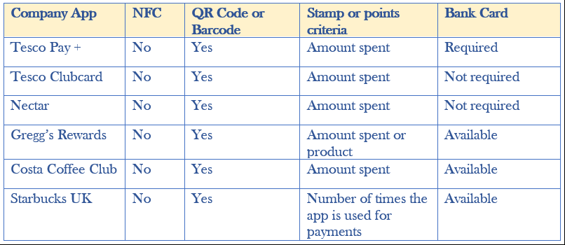

Figure .Comparison of company mobile loyalty apps features and loyalty scheme details

From this overview (see Figure 13), it is clear that the NFC technology is still not used for loyalty schemes. In the Tesco Pay + case, the loyalty point collection is incorporated within the payment solution so the customer does not need to do additional scanning or verification because it is automatically done within the company services (Tesco, 2020).

Gregg’s Rewards and Costa Coffee Club are relatively similar to the Caffè Nero scenario (see 2.2.6.1) while Starbucks is different. The latter rewards the customer if paying using a pre-loaded Starbucks Card that can be added into the app.

## Review Of Tools And Techniques

There is a variety of tools to work with NFC. In this section an analysis is carried on to give a list of possible approach for the intended solution.

### Mobile Native Android Application

A first popular solution for a software with NFC is to make a mobile application. It is the most flexible because it allows people to use the full potential of the technology.

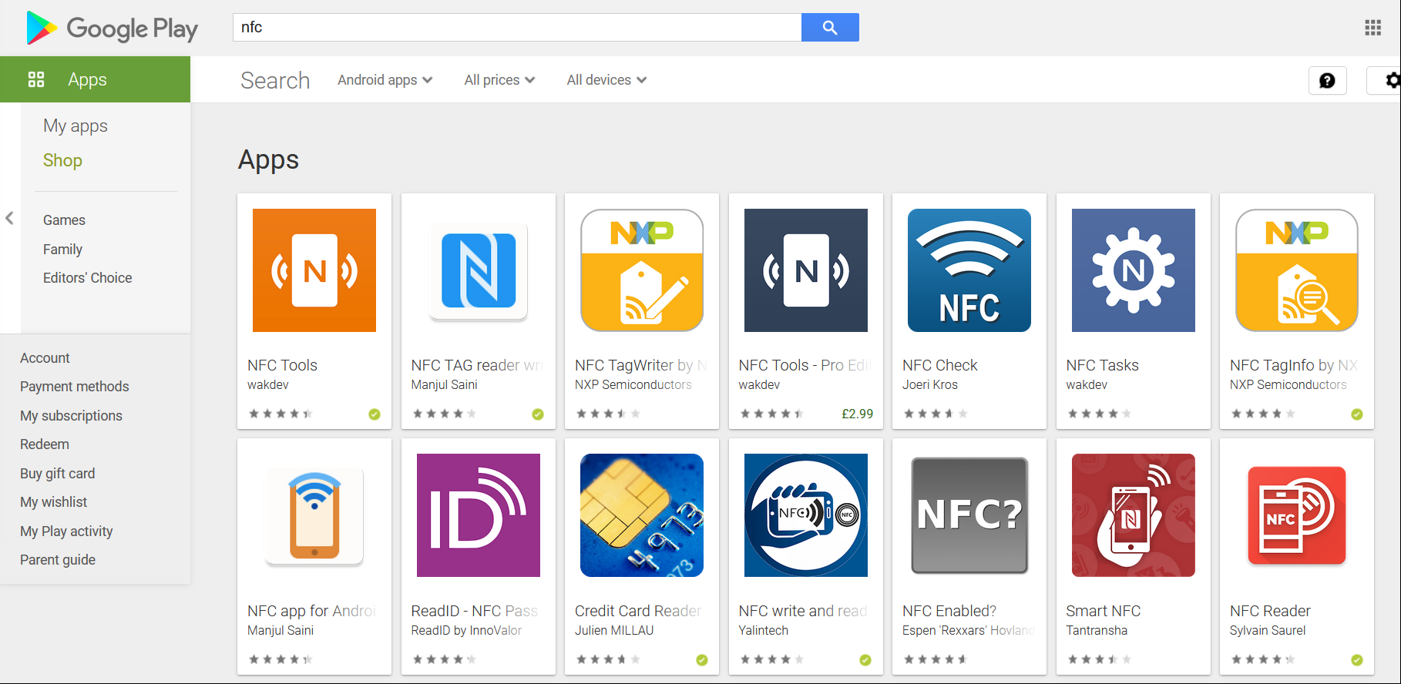

Figure . NFC application search result on Google Play (Search made on July 2020)

There are plenty of applications that can enable the user to interact with NFC (see Figure 14). Also, even if the user did not have any application installed, it can automatically respond to the data inside the tags because of the Android OS. For example, if a user has saved a URL link into a tag. Whoever scans it will open the default browser and go to the website saved (Frew, 2020).

Advantages:

* Full capability of the NFC technology. Includes HCE used for payments and peer-to-peer communication.
* Limited only by the specification of the device.
* The operating system must approve the app, so it assures quality, security, and device compatibility.
* The app can receive support from the app stores to help distribute the product.
* Can work offline without internet connection.

Disadvantages:

* Slow to develop and very hard to update. It would require constant updates from the customer even for small changes.
* Difficult to maintain once there are many different devices using it on different versions.
* Cannot work on other OS devices.

#### Mobile Native iOS Application

Similar to the previous technique (see 2.3.1), iOS applications are subject to the same features and problems. Unlike Android, the possibility to read and write from NFC tags on iOS has been introduced only in the Autumn of 2019 even though the capability was already in the devices long ago (BlueBite, 2020).

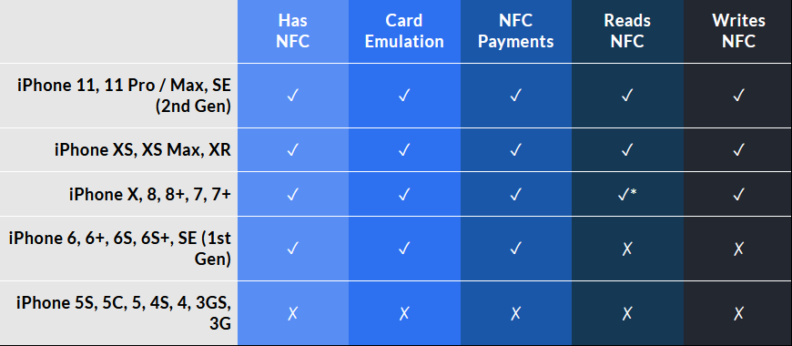

Figure . NFC features enabled on iOS smartphones

To avoid repetitiveness regarding the advantages and disadvantage, please refer to the list in *2.3.1 Mobile Native Android Application*.

### Web Application

Thanks to the W3C community Group there is a capability to read and write NDEF messages on tags through Google Chrome browser on mobile (Kostiainen, 2019). This gives the opportunity to design a Web App with NFC features to enhance the UX like never before.

A Web App is what is commonly known as a Website that uses improved back-end capabilities to perform specific task. It is a software that is made to be accessible by any web browser.

Advantages:

* Easy maintenance.
* Cross platform among all the smartphones.
* Updates do not require any new installation or action from the user.
* Low cost for the implementation and deployment on the internet.
* The data stored are not on the user device and therefore no data limitation.

Disadvantages:

* Harder to discover because not listed in a marketplace.
* Slower and less responsive than the native apps.
* Relying on the internet connection.

### Hybrid App

These types of mobile applications are considered to be something between a Web App and a Native Mobile Application. They are installed on a mobile device like an app, but in order to work they need to surf the internet like a Web App.

Advantages:

* Require only one codebase across all mobile platforms.
* Easier to update depending when the changes are not related to the native code.
* Updates do not require any new installation or action from the user.
* Combines the best from the user experience and the agile development cycle.

Disadvantages:

* Compared to the native application they are less performant.
* Higher is the customisation needed and higher than the native application is the difficulty of implementation.
* Relying on the internet connection.

### .Net Core 3.1

.NET Core 3.1 is currently the latest version of the ASP.NET CORE Microsoft frameworks. It is a web development framework for building Web Applications, services and console application. It is open-source and based on .NET platform (Microsoft, 2020).

Advantages:

* Works on multiple platforms such as Windows, Linux and Mac.
* It is fast and scalable to work the modern libraries and programming languages.
* The architecture of the system is modular. It gives the possibility to modify a component without affecting the rest of the system.
* Uses C# as main programming language.

Disadvantages:

* It has many features not yet fully developed, although it will be updated over and over.
* It has memory leaks that increase the quantity of data not used.

### .Net Framework

.NET Framework is the framework solution created by Microsoft before .NET Core for the same purpose. It is used to develop Web Applications, service and console applications on Windows.

Advantages:

* Has more functionalities than the other new framework although there should be less over time.
* The longer presence in the market means a higher number of solutions and documentation among the users.
* Uses C# as main programming language.

Disadvantages:

* It is not open source.
* Development restricted on Windows platform.

### Entity Framework

Entity Framework is an open-source Object-relational Mapping framework for .NET applications supported by Microsoft. It gives the developers the option to work with the database through .NET objects in the software with more flexibility.

Advantages:

* It is developed as an Open Source product.
* It has stored procedures support.
* It provides auto generated code that simplifies the development time and cost.

Disadvantages:

* It handles data in a different way from SQL.
* Strictly linked to the database schema. It requires constant updates to match the tables in the source solution.

### QR Code generation

This type of approach for the intended project development is possible. In fact, there is a possibility of using QR code generation for the representing the loyalty card with a unique ID in the same way as the previously mentioned applications (see Review of Projects / Applications2.2) but this project also aims to demonstrate the capabilities of the NFC and what alternatives it can present with the latest technologies.

Advantages:

* Versatility of being used for different purposes.
* Very-low cost to use and easy to implement.

Disadvantages:

* Must be scanned through a device that has a camera and understand what data is the QR code representing.
* The camera quality must be enough to clearly capture the image.
* The data represented by the code can only hold up to 3Kb.

# Requirements

This section presents a review of the different stages of the software development process. The initial step is the identification of the project goal. Based on the goal, it is possible to provide a list of function and non-functional requirements that the system must have. This process is known as Requirements Engineering or Gathering.

The following sections provide a presentation of the stakeholders, the project promises and the issues related to the legal and ethical aspects.

## Stakeholders

The stakeholder is defined as a person who is involved with an organization and has responsibilities and interest its success (Cambridge Dictionary, 2020).

Creating an onion model is considered a good approach to understand the stakeholders structure of the project (Alexander & Beus-Dukic, 2009).

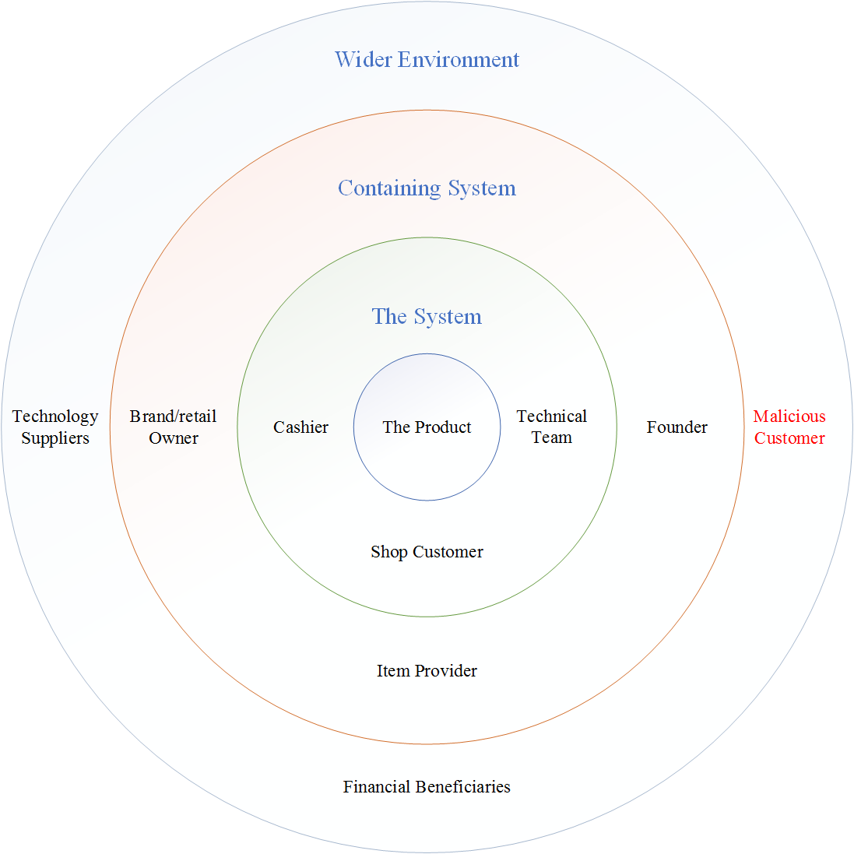

Figure . Basic Onion Model stakeholders

In the figure above (see Figure 16), the inner circle there is The Product which is the Web Application meant to be created (i.e. Contactless Loyalty).

The Systemlayer contains the essential part of the product and service, the people who interact directly with it. Therefore, there is the cashier, who will allow the customer to scan the tag through the Web App, so that the customer will receive the loyalty point (i.e. Stamp on the card). The technical team will be the people maintaining the service up and running smoothly. They will deal with the customer or cashier in case of product issues.

In the Containing System there are the brand or retailer owners that are the people who decide to use this service to be applied in their shops. The Item provider is whoever provides the final rewarded product to the customer (e.g. A free coffee, a free meal or a discount). For example, if the brand or retailer is a supermarket (e.g. Tesco) they can reward customers with different items in the shop (e.g. Chocolate bars) but they are not the original item provider, meaning they do not create the item. Although depending on the scenario, they could be the same stakeholder. If the retailer owner is a small shop like a coffee stand in a street food market, they will automatically be also the item provider. Ultimately, this layer contains stakeholders that may not interact with the product directly, but they get advantage from it like brand or product awareness.

In the last layer, Wider Environment, there are financial beneficiaries such as stockholders and the public in case of a public impact and similar entities. Moreover, the providers of the Web NFC API, Microsoft Azure for cloud services and NFC tag suppliers are considered to be the technology suppliers who are not directly involved with the product but are still related to it as an intermediate. There is also a consideration for possible hackers or malicious customers that intend to steal and illegally take advantage through this service.

## Gathering requirements

To gain a more knowledge on the demand of this type of project, a survey has been carried out along with interviews and statistical analysis.

### Statistical Analysis

The project basic requirements have been decided using online resources and documentation about loyalty card schemes.

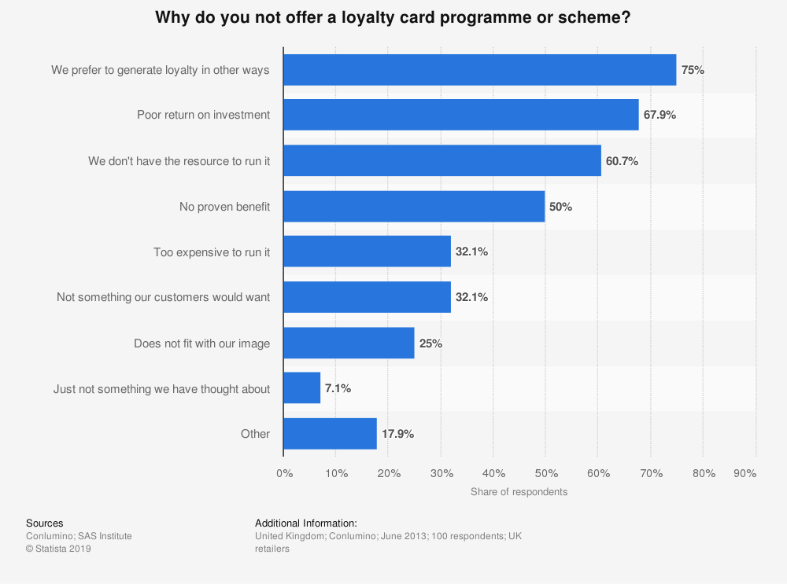

Figure . Classification of reasons for not offering a loyalty scheme

The data shown above (Figure 17) shows that the top three drawbacks for offering a loyalty scheme to the customers from the point of view of UK retailers are:

1. Not interested in the card programme.
2. Poor return on investment.
3. Not appropriate resource to run the scheme.

This project can tackle the second and third problem. It provides a very low-cost technology, as well as a service that can be included with a membership cost to charge while the scheme is active.

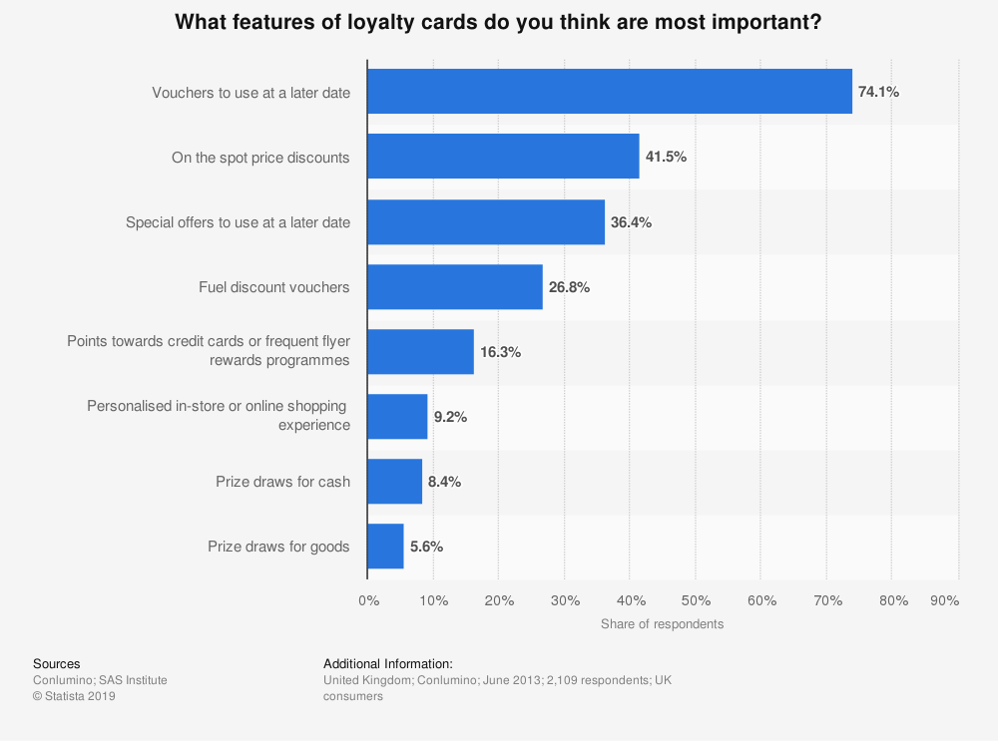

Figure . The most important features of a loyalty card for consumers

The data shown above (see Figure 18) provides a classification of the most valued features for the UK consumers. It is evident that the most important factor is the ability to use vouchers at a later date.

Although the software for the voucher rewards has not been implemented in this project, it is included with the involvement of a digital voucher company (i.e. i-movo). The back-end of the Web App can validate the reward when collecting points and tracking when to reward the customer. At the right moment, the Web App will allow the user to decide to receive the digital voucher by SMS on their phone from i-movo through an API. The external company provides a secure voucher system that sends out different type of vouchers where different parameters, such as voucher expiry date, can be customised depending on the retailer or client needs.

### Survey Analysis

The survey has been made online through Google Forms and the answers have been analysed (using what?) for further needs.

### Interviews and Feedbacks

Further feedbacks and comments have been taken through interviews with the stakeholders such as potential customers and loyalty scheme providers.

* Laurence – user registration security and data modelling
* David – engage with the customer to make it appealing to use and become aware of the brand
* Toby for voucher system to be sent through mobile and not email – date validation – scheme validation
* Alessandro – Date validation and scheme
* Takefumi Yoshi for tag id as serial number and identification
* Lincoln for initial help and support

## Modelling requirements and relevant diagrams

In the following sections the description and diagrams relevant to this scenario are provided to support the software decisions.

### Use Case Model

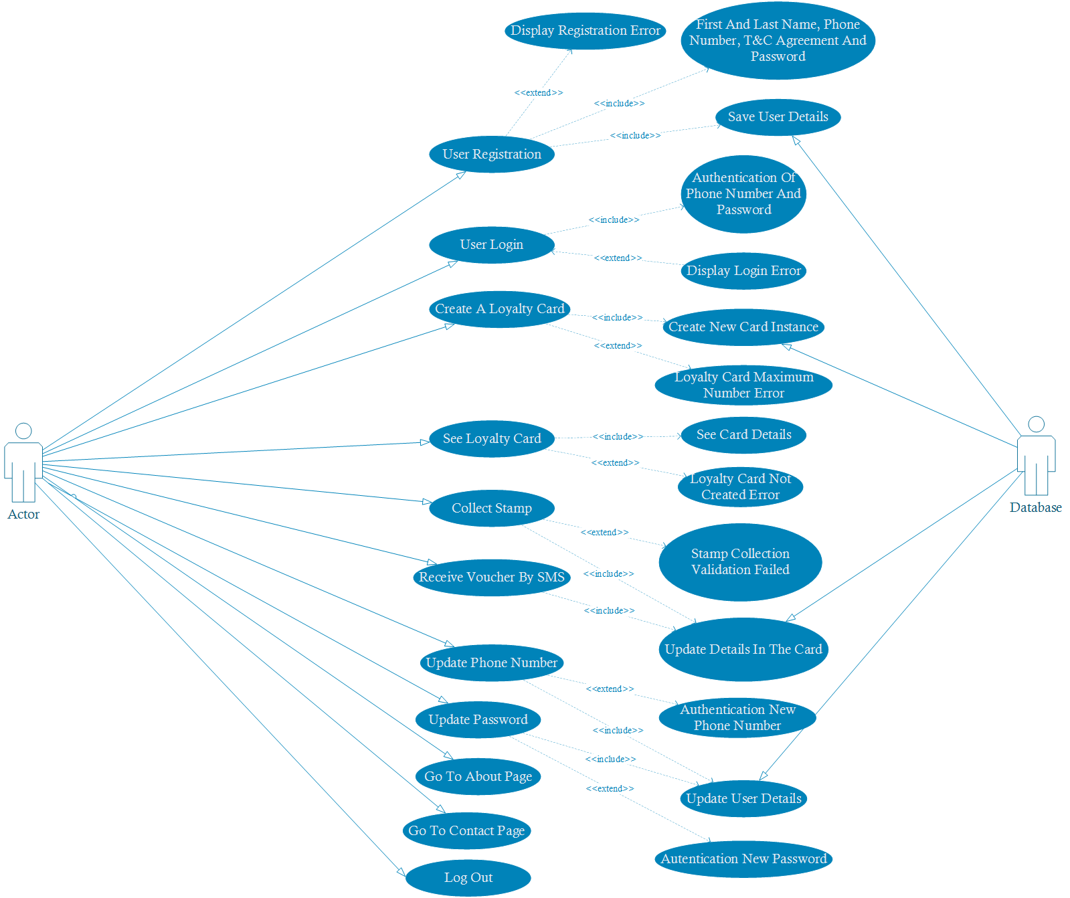

Figure . Use Case Diagram

The above diagram shows all the possible actions that a user can do in the Web App.

### Use Case Description

|  |  |
| --- | --- |
| **Use Case ID** | UC0 |
| **Use Case Name** | Registration |
| **Description** | This use case is for when a user attempts to register on the Web App by providing some details such as First and Last Name, Password Mobile Phone Number and accepting the Terms and Conditions. |
| **Primary Actor** | Customer User |
| **Pre-Conditions** | Web App shall be up and running and the user must have clicked the Register button. |
| **Post Conditions** | The system validates the input data and the details are stored in the database. The user is automatically redirected to the internal homepage after successful registration. |
| **Main Success Scenario** | 1. The user clicks on the Register Button. 2. The user enters all the details (First Name, Last Name, Mobile Phone Number, Password, Confirm Password and checks the box for agreeing the Terms and Conditions). 3. The system performs a data validation. 4. The system updates the database with the new information. 5. The system automatically logs in the user with the information just saved. 6. The system shows the internal home page. |
| **Exceptions** | * The user enters a mobile phone already saved in the database. * The password is shorter than 6 characters. * The password does not contain uppercase. * The password does not contain lowercase. * The password does not contain a digit. * The password does not contain a special character. * The password and confirm password do not match. * The phone number entered is not UK format. * The user has not accepted the Terms and Conditions. |

Table .Use Case Description (UC0)

|  |  |
| --- | --- |
| **Use Case ID** | UC1 |
| **Use Case Name** | Login |
| **Description** | This use case is for when a user attempts to sign into the Web App with a Mobile Phone Number and Password. |
| **Primary Actor** | Customer User |
| **Pre-Conditions** | * Web App shall be up and running. * User must have previously registered in the Web App. * User must be in the login page. |
| **Post Conditions** | * The system validates the input data with the details stored in the database. * The user is logged in and can choose all the internal features. |
| **Main Success Scenario** | 1. The user clicks on the Sign In Button. 2. The user enters Mobile Phone Number and Password. 3. The system performs a data validation. 4. The system shows the internal home page. |
| **Exceptions** | * The user enters a Phone Number not saved in the database. * The Password and Password in the database do not match. * The user has not entered any data. |

Table . Use Case Description (UC1)

|  |  |
| --- | --- |
| **Use Case ID** | UC2 |
| **Use Case Name** | Create New Loyalty Card |
| **Description** | This use case is for when a user clicks on Create New Loyalty Card button. |
| **Primary Actor** | Customer User |
| **Pre-Conditions** | * Web App shall be up and running. * User must be logged in. * User has pressed the Create New Loyalty Card button. |
| **Post Conditions** | * The system generates default details for a new card. * The user can see the new card on the Card page. |
| **Main Success Scenario** | 1. The user clicks on the Create New Loyalty Card button. 2. The system generates a default loyalty card. 3. The system updates the database with the new card details. 4. The system shows the card details page. |
| **Exceptions** | * The user has already an existing card. Currently the limit is set to be one card per customer. |

Table . Use Case Description (UC2)

|  |  |
| --- | --- |
| **Use Case ID** | UC3 |
| **Use Case Name** | See Loyalty Card |
| **Description** | This use case is for when a user clicks on See Your Loyalty Card button. |
| **Primary Actor** | Customer User |
| **Pre-Conditions** | * Web App shall be up and running. * User must be logged in. * User has pressed the See Your Loyalty Card button. |
| **Post Conditions** | * The system shows the customer card details such as loyalty points. |
| **Main Success Scenario** | 1. The user clicks on the See Your Loyalty Card button. 2. The system retrieves the card data linked to the user. 3. The system shows the details of card in a new page. |
| **Exceptions** | * The user does not have a card created yet. |

Table . Use Case Description (UC3)

|  |  |
| --- | --- |
| **Use Case ID** | UC4 |
| **Use Case Name** | Collect a Stamp by Scanning |
| **Description** | This use case is for when a user clicks on the Start Scanning button. |
| **Primary Actor** | Customer User |
| **Pre-Conditions** | * Web App shall be up and running. * User must be logged in. * User must have pressed the See Your Loyalty Card button. * User clicks on Start Scanning button. * User must have accomplished the condition to receive the NFC tag or Smart Card to scan from the cashier. * User must enable NFC on the smartphone. * User must allow the Web App to use NFC. * User must be on Android. * User must be on Chrome or Chromium mobile browser. * User must have a Loyalty Card registered in the database. |
| **Post Conditions** | * The system refreshes the page. * The system shows the updated data of the card. |
| **Main Success Scenario** | 1. The user clicks on the Start Scanning button. 2. The user scans an appropriate NFC tag or Smart Card. 3. The system validates the scansion. 4. The system updates the record of the card in the database. 5. The system refreshes the page with the new data to display. |
| **Exceptions** | * The NFC tag or Smart Card is not correct. * The NFC tag does not have an expected scheme code. * The NFC tag Serial Number is not expected. * The user has exceeded the number of collections by either hour, day or week. |

Table . Use Case Description (UC4)

|  |  |
| --- | --- |
| **Use Case ID** | UC5 |
| **Use Case Name** | Collect a Stamp by Mock Collection |
| **Description** | This use case is for when a user clicks on the Mock Collection button. |
| **Primary Actor** | Customer User |
| **Pre-Conditions** | * Web App shall be up and running. * User must be logged in. * User must have pressed the See Your Loyalty Card button. * User clicks on Mock Collection button. * User must have a Loyalty Card registered in the database. |
| **Post Conditions** | * The system refreshes the page. * The system shows the updated data of the card. |
| **Main Success Scenario** | 1. The user clicks on the Mock Collection button. 2. The system validates the attempted action. 3. The system updates the record of the card in the database. 4. The system refreshes the page with the new data to display. |
| **Exceptions** | * The user has exceeded the number of collections by either hour, day or week. * The user has maliciously changed the values in the Mock Collection button. |

Table . Use Case Description (UC5)

|  |  |
| --- | --- |
| **Use Case ID** | UC6 |
| **Use Case Name** | Receive voucher by SMS |
| **Description** | This use case is for when a user clicks on the Receive Voucher button. |
| **Primary Actor** | Customer User |
| **Pre-Conditions** | * Web App shall be up and running. * User must be logged in. * User must have pressed the See Your Loyalty Card button. * User must have collected enough points or stamps (by default 9) to receive the reward. |
| **Post Conditions** | * The system shows the voucher sent page. * The user receives an SMS with the digital voucher. |
| **Main Success Scenario** | 1. The user clicks on the Receive Voucher button. 2. The system successfully makes the API request to send the voucher. 3. The system updates the record of the card in the database. 4. The system redirects the user to the voucher sent page. |
| **Exceptions** | * The user has not collected enough points or stamps. Hence, the button will not display. * The user has an invalid phone number saved. |

Table . Use Case description (UC6)

|  |  |
| --- | --- |
| **Use Case ID** | UC7 |
| **Use Case Name** | Change Phone Number |
| **Description** | This use case is for when a user clicks on “Profile” under the Manage account menu button. |
| **Primary Actor** | Customer User |
| **Pre-Conditions** | * Web App shall be up and running. * User must be logged in. * User must be in the Profile section of the Manage Account |
| **Post Conditions** | * The system shows the updated phone number on the page. * The system shows a statement as a response. |
| **Main Success Scenario** | 1. The user clicks on the Manage Account button from the menu options (Hamburger menu button). 2. The user edits the Phone Number field. 3. The system validates the new Phone Number. 4. The system updates the user record in the database. |
| **Exceptions** | * The user has not changed the phone number. * The user is changing phone number to one already existing. * The user is using an invalid phone number format. |

Table . Use Case Description (UC7)

|  |  |
| --- | --- |
| **Use Case ID** | UC8 |
| **Use Case Name** | Change Password |
| **Description** | This use case is for when a user clicks on “Password” under the Manage account menu button. |
| **Primary Actor** | Customer User |
| **Pre-Conditions** | * Web App shall be up and running. * User must be logged in. * User must be in the Profile section of the Manage Account. |
| **Post Conditions** | * The system shows the updated phone number on the page. * The system shows a statement as a response. |
| **Main Success Scenario** | 1. The user clicks on the Manage Account button from the menu options (Hamburger menu button). 2. The user selects the Profile section. 3. The user enters Current Password and the New Password twice. 4. The system validates the New Password. 5. The system updates the user record in the database. |
| **Exceptions** | * The user has not changed the password. * The user is changing phone number to one already existing. * The user is using an invalid phone number format. * The password is shorter than 6 characters. * The password does not contain uppercase. * The password does not contain lowercase. * The password does not contain a digit. * The password does not contain a special character. * The password and confirm password do not match. |

Table . Use Case Description (UC8)

|  |  |
| --- | --- |
| **Use Case ID** | UC9 |
| **Use Case Name** | Visit About or Contact page |
| **Description** | This use case is for when a user clicks on About or Contact from the menu button. |
| **Primary Actor** | Customer User |
| **Pre-Conditions** | * Web App shall be up and running. * User must be logged in. |
| **Post Conditions** | * The system shows the About or Contact page |
| **Main Success Scenario** | 1. The user clicks on the About or Contact button from the menu options (Hamburger menu button). 2. The system shows the page content. |
| **Exceptions** | * The page is not found. |

Table . Use Case Description (UC9)

### UML (Unified Modelling Language)

Figure . Main Class Diagram of the Contactless Loyalty Web Application

### ERD (Entity Relationship Diagram)

The following diagram (see Figure 21) shows the structure model of the Web Application. Because of the solution initially provided the database is relatively simple. The main two tables are the AspNetUsers and LoyaltyCards. The former has automatically created attributes that will be user in future stage of the software.

The AspNetUsers is identified with an ID used a Primary Key and it will also have a UserName matching the PhoneNumber, FirstName, LastName along with a PasswordHash.

The LoyaltyCards have an ID as Primary Key and the attributes: LastStampDateTime, NumberOfVouchers, NumberOfStamps, Storename, StoreSchemeCode and Foreign Key UserId associated with the AspNetUsers table.

Since the user is one and he will be able to store zero or more cards, the multiplicity of the relationship is one to many. The AspNetUsers table will have participation and cardinality 1 while LoyaltyCards will have 0 participation and many as cardinality.

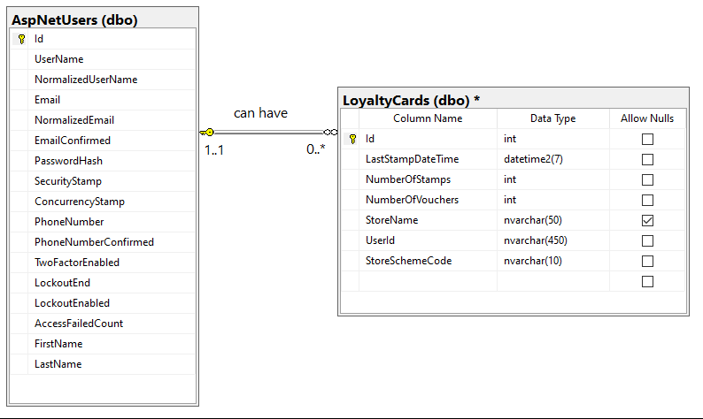

Figure . Database ERD

A future implementation for improved user management in the database could look like the diagram below (Figure 22) where the user can have the possibility to have a two factor authentication using a token and can hold different roles.

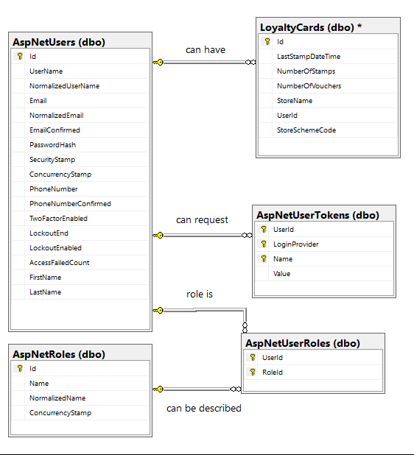

Figure . Possible database design with more user management

## List of Project Requirements

In this section a table with the list of functional and non-functional requirements is shown.

The list is made following two systems called Simple Ranking and MoSCoW.

The former is a method that ranks the requirements importance by a number from 1 to n, where higher the number and least important it is (Hatton, 2008).

The latter is a hierarchical priority method that uses four different groups (Hatton, 2008).

1. MUST have: the failure to deliver these requirements would cost the success of project.
2. SHOULD have: characteristics that would be good to have if possible.
3. COULD have: features that would be nice to have but not valuable as the second group.
4. WON’T have: also called “wish list”, are the requirements that are still important but that will be implemented in a future stage.

### Functional Requirements

The following table shows the list of requirements based on the initial feedbacks and desired functionality from the stakeholders.

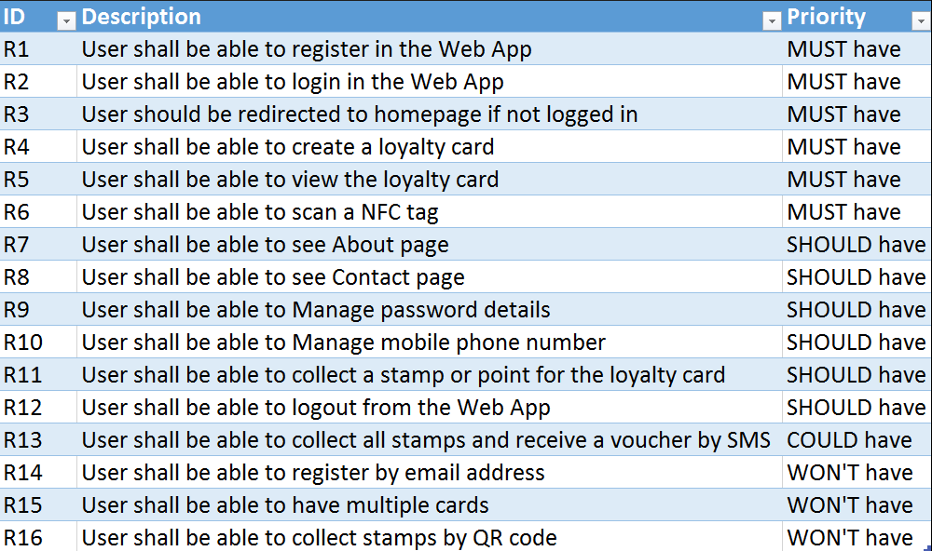

Figure . Table of functional requirements

### Non-Functional Requirements

The following table shows the list of qualitative requirements that do not involve the final service of the software.

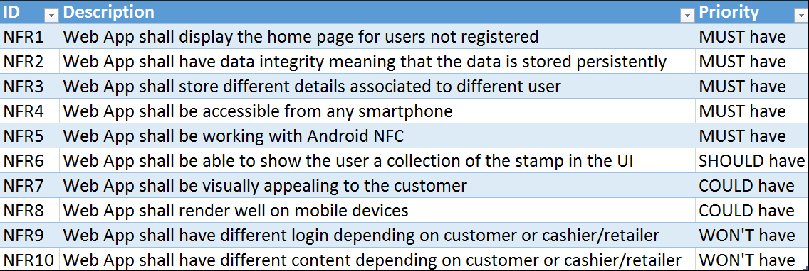

Figure . Table of non-functional requirements

## Legal, Social and Ethical Issues

This section takes into consideration the different issues exposed to this project.

### GDPR (General Data Protection Regulation)

On the 14th April 2016, the European parliament ratified the GDPR to give users more data and privacy protection.

Articles 13 and 14 state that the user must have access to information where the personal data is collected, how it is processed, and the duration which the data is kept. To comply with these regulations, the registration process includes a consent field to allow Contactless Loyalty to process the data provided. This field is an agreement checkbox where the user can see how the data is used and collected.

The Article 15 (intersoft consulting, 2016) of the aforementioned law, explains the right to access the data collected. This Web App project is built to prevent unauthorised access to its data from a third-party organisation. It will give appropriate access only to authorised individuals.

The application is designed in a way that the user data information is stored only where necessary and consented (i.e. *Remember me* and *Cookie policy* options). Data entered by the user is also sanitised to prevent code injection wherever possible. The data stored in the registration process such as password is protected with HMAC-SHA256 (i.e. Hash-Based Message Authentication Code using SHA256 Algorithm), 128-bit salt, 256-bit subkey, 10000 iterations (Haggerty, 2020).

### Intellectual Property

The intellectual property of this project belongs to the student developer and the University of Westminster. This is to protect against invention theft, design, look and brand of this product. Although not officially registered, this is a recognised piece of work from the University of Westminster.

This Web Application also includes some contents adapted from online open source designs, hence a reference to those are appropriately added in the source code.

### Environmental

As previously mentioned (see 1.1), this project also aims to be eco-friendly.

Avoiding the production of plastic and paper cards can be very beneficial for the environment because it prevents the waste of materials(Robertson, 2018). Even though this solution still requires the use of NFC tags, which is made out of coils, plastic and glue (Seritag, 2020), it is still significantly less than those used for creating cards. Moreover, the NFC tag can be programmed again by the retailer avoiding the need of producing or buying new tags.

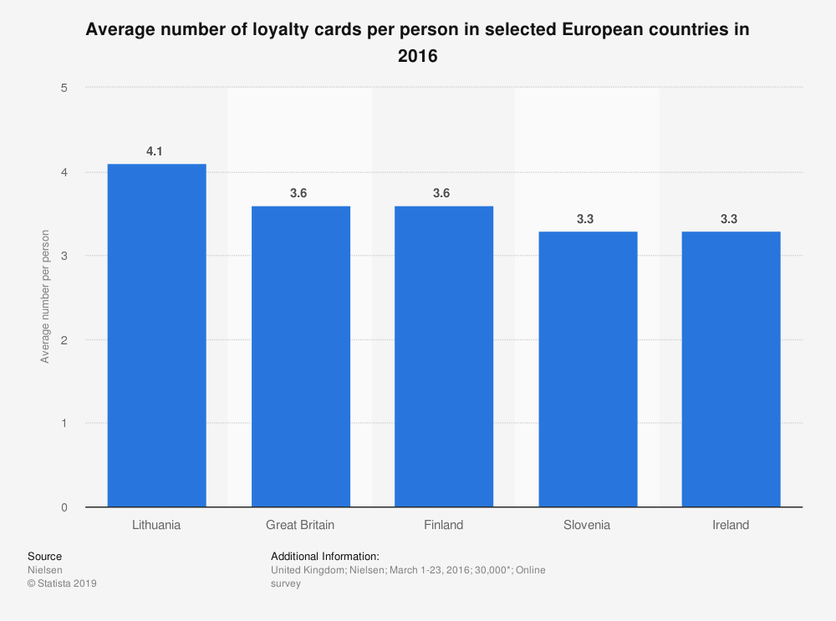

Figure . Average number of loyalty cards per person

Combining the previous factor to the statistic of cards per person (see Figure 22), it is possible to point out that by using this solution a lot of waste can be reduced. This is because each person could have 3 digital cards in place of the physical cards.

# Methodology

Scrum Agile development methodology was chosen over the traditional software development such as the Waterfall method because of its scalability and flexibility (M. Mahalakshmi, 2013).

Although agile may produce less documentation of the software (Vijayasarathy & Turk, 2008), it is fair to say that the current development is carried out by just one person. Therefore, there is no need for much documentation regarding the application in the early stage of the project. In any case, GitHub will be used as version control tool that can also provide enough documentation about the software.

Moreover, a big advantage of this technique is the early involvement of the stakeholders (Yu Beng Leau, 2012). This aspect means they can provide constant feedback on the prototype delivered, which is crucial for testing and demand purposes.

## Early Iterations of The Project

It is sensible to mention the fact that, initially, the project was intended to be developed through a Mobile Native Application (see Figure 26). Eventually, the new approach was taken because later in the stage, the new capability of the same feature (i.e. Web-NFC) was released and discovered. This was possible thanks to the methodology chosen.

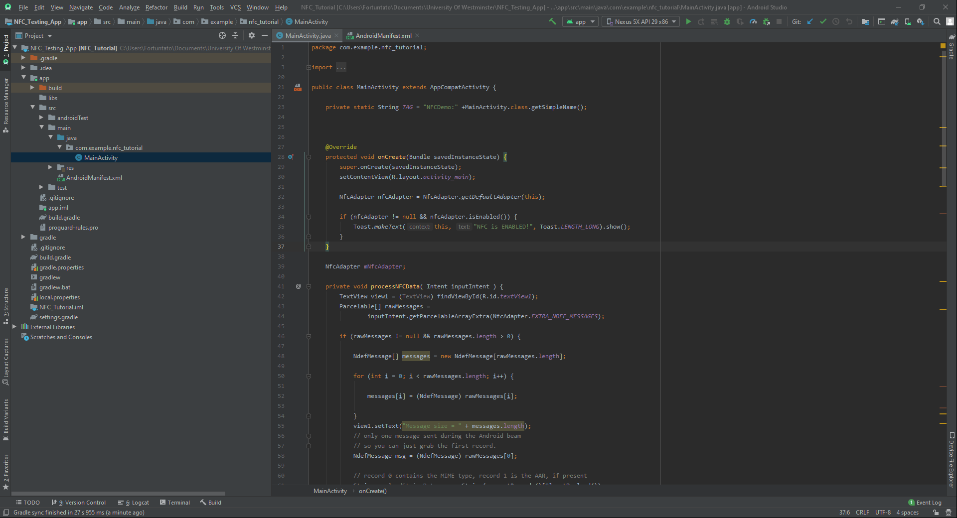

Figure . Android Studio project prototype

The initial part of the project was solely concentrated into the research aspect. Being new to the technology implementation, many resources were used to gain knowledge and experience. The first major source was the draft documentation written by W3C ( <https://w3c.github.io/web-nfc/> ). Additional guidance was found in the issues board on GitHub ( <https://github.com/w3c/web-nfc/issues> ). Using these information, a Web Application was created as a playground of the new key features during the primary iterations of the project.

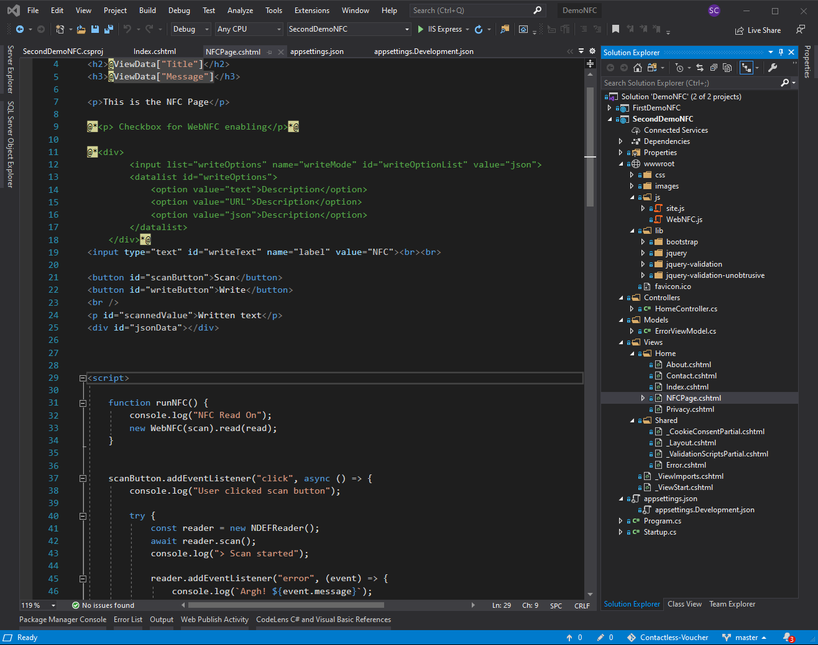

Figure . Initial Web App to test Web-NFC (source code)

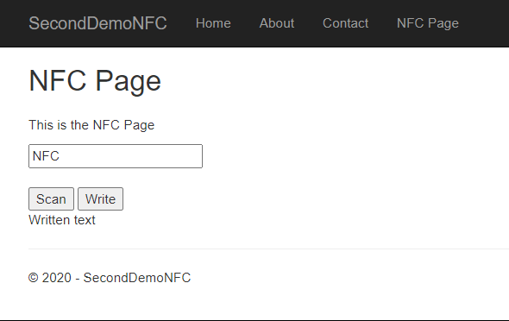

Figure . Initial Web App to test Web-NFC (front page)

Thanks to these initial steps, a list of possible features was created and the interviews with the stakeholders were planned. These made the project take a direction towards the current final solution.

## Iterations with Stakeholders

Throughout the project development, the potential users were always in contact and providing opinions and ideas. Adapting the software to the new designs was possible and practical thanks to the weekly or daily sprints. This key advantage of being able to adjust the software in terms of needs was the prove of the right methodology used.

The core idea of the digital loyalty card was ready to be implemented, but the way the Web App was initially built was different.

The development was following the real business scenarios considered. In fact, this project can be counted as a real case study because of the various commercial aspects (e.g. Loyalty scheme completely digital, innovative and interactive). The initial iterations were created to make sure that the essential legal and ethical issues were met. Therefore, the user registration and login functionality were implemented first. Later, the actual digital card was introduced. Finally, the Web-NFC capability was embedded into the project.

Further changes and design issues were resolved in order to improve the final result.

# Design

This chapter describes the design solutions for the previously indicated requirements on the front-end and back-end (see 3.4).

Before starting, it is necessary to point out that the Web App is designed to be visited only on smartphone devices. Although, the Web App is accessible by all the platforms, the design issues are not concerned by the alternative layouts because the main capability of the Web-NFC is only available through the smartphone. Therefore, it would not make any sense to implement an optimised design for a desktop version.

## Colour Scheme and Palette

In order to choose an appropriate colour scheme, two major companies where taken into account: Pantone and Adobe (i.e. Adobe Color Blog more specifically).

Adobe is a popular software company that provides powerful tools for designers to create their work and has a big community of artists.

Pantone provides a colour matching system that is the main influence in colour design and trends over the years (Velarde, 2019). The colour chosen for the year 2020 is Classic Blue.

The colour tries to convey a sense of calm, confidence and connection (Milis, 2019). Based upon these values and the colour palette suggested in the Adobe’s blog the following colour scheme was chosen (see Figure 29).

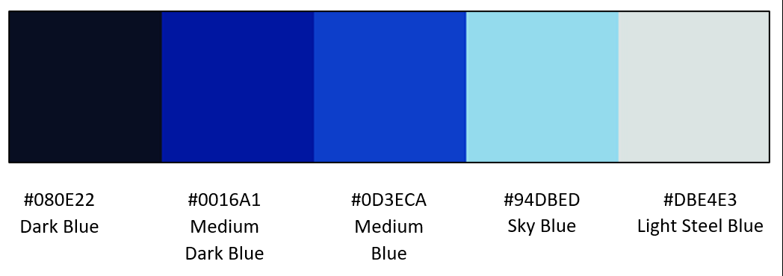

Figure . Colour palette for the Web App

These colours are dominant in the whole website, the Dark Blue has been used for the background to give a sense of a dark mode. In contrast, the Light Steel Blue has been used for the text colour as well as some menu options. A gradient of the colour spanning from Medium Dark Blue to Sky Blue has been used for the buttons and the navigation bar. In the banner (see Figure 30) at the top of the login and registration page, all the colours are used.

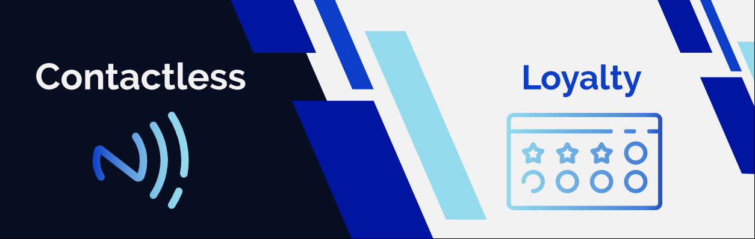

Figure . Banner used at the top of the landing page

## CSS and Bootstrap

Regarding the font type, size and general layout of the page CSS and Bootstrap were used.

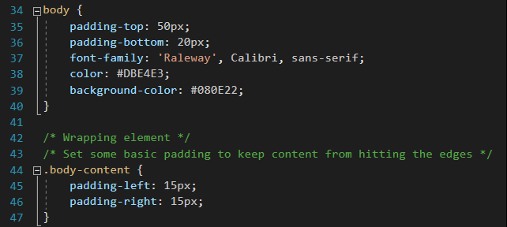

Figure . CSS body style and body content padding

For example, in the figure above (see Figure 31) the default font type “Raleway” has been declared. To make sure the website could find the font-family, there is a reference to the Google Forms library in the head tag of the layout page (i.e. _Layout.cshtml).



Figure . Font-family library source declaration

The open source Bootstrap framework has been used for the layout formats as well as making sure the elements on the page were appropriately placed.

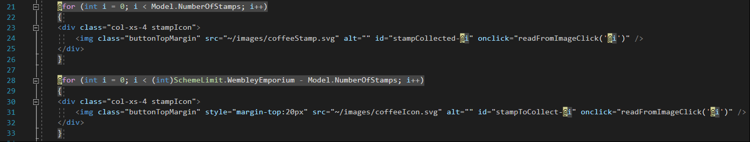

Figure . Code showing the Stamps on the Loyalty Card page with Bootstrap class layout (col-xs-4)

## Razor Page

Razor pages are a type of page which are created with ASP.NET Core framework which helps build dynamic and data-driven web sites (Anderson & Nowak, 2020).

With this capability in mind, the most important page of Contactless Voucher (i.e. Loyalty Card Page. See Figure 38) is implemented dynamically depending on the data retrieved from the database. As shown in the Figure 32 (lines 21 and 28), it is possible to integrate the page with C# code. This makes it convenient to manage the content of the page and integrate advanced layers of security such as Forgery Token validation.

Moreover, it has been discovered and tested, during the sprints, that C# could also be used in the JavaScript section of the page. This has shortened the code implementation and allowed the essential feature of posting the retrieved data back to the controller from the tags.

## SVG Images

The use of SVG (Scalable Vector Graphics) such as the banner (Figure 30) were used for the Loyalty Card page. They make it possible to maintain the same image quality no matter the size of the page. This was a good reason to use these type of illustrations. The main two coffee vectors were taken from Flaticon ( <https://www.flaticon.com/> ) and then edited to match the colour scheme and size of the pages.

Machine generated alternative text:
flaticon 
Authors 
Packs 
More Tools • 
Search more icons in this style 
Style: Lineal x 
Become a contributor 
Pricing Login 
Q 
Register 
o Collections 
Icons • 
P Save 
Search for icons and packs 
(Z Edit icon 
Intemet Technology 
Register for free and download the full pack 
Register & Download 
Smartphone free icon 
PNG 
* Add to collection 
Flaticon License 
SVG 
Free for personal and commercial purpose with attribution. More info 
Attribution is required. How to attribute? 
Vitaly Gorbachev 
View all 39,710 Icons 
More icons from Intemet Technology pack 
Style: Vitaliy Gorbachev Lineal 
NFC 
Follow 
Get 10 free Icons 
Adobe Stock 
st 
Sponsored results by 
NFC 
D)) 
000 
NFC 

Figure . Flaticon image research

### Adobe Illustrator

This is the tool used for editing the SVG image. It is a software developed by Adobe and it has a lot of capabilities such as creating vectors out of a PNG image.

Due to the previous experience with this program, it was a reasonable decision to edit the images with it.

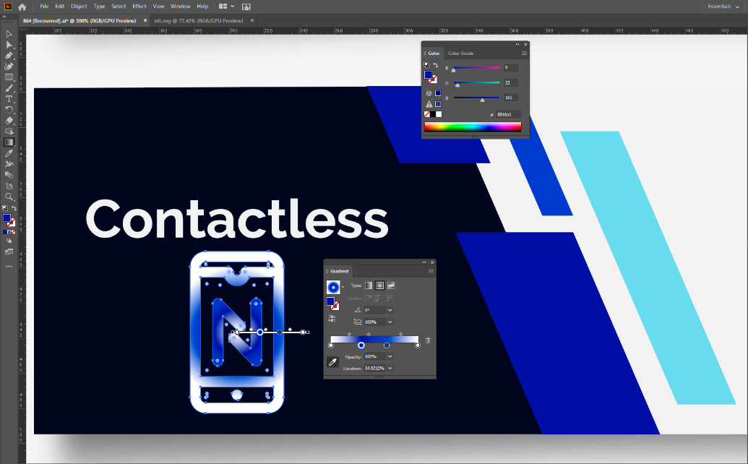

Figure . Adobe Illustrator banner template in development

## Web App Wireframes with Flowchart

The wireframes of the Web App with corresponding flowchart are presented. For the illustrations please refer to this legend (see Figure 35) for the colours and shapes used.

Testo alternativo generato dal computer:
Process 
Subprocess 
Decision 
Start/End 

Figure . Flowchart legend

In the scenario in which the flowchart does not show the shape corresponding to “End”, it is because it has been replaced with the last application wireframe linked.

### Login and Registration

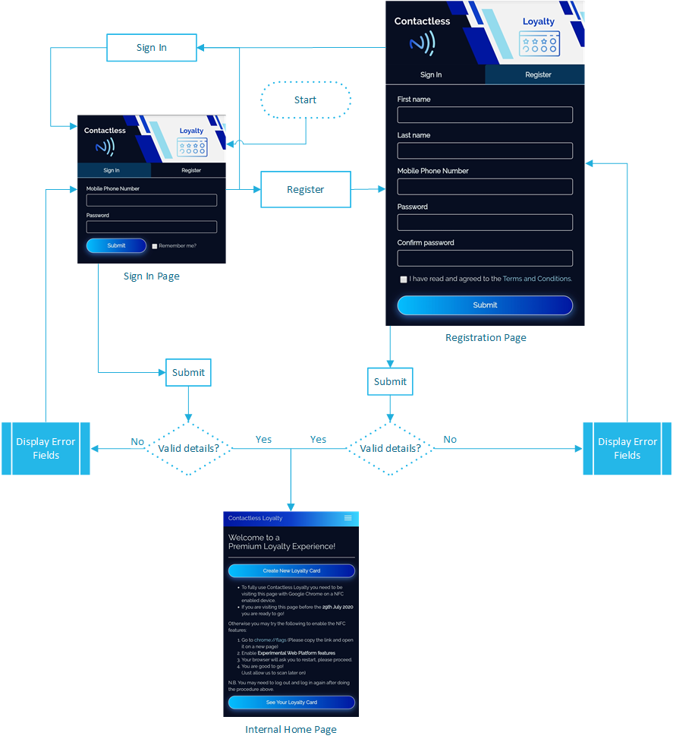

Figure . Login and Registration Flowchart with Wireframes

### Internal Home Page after Login

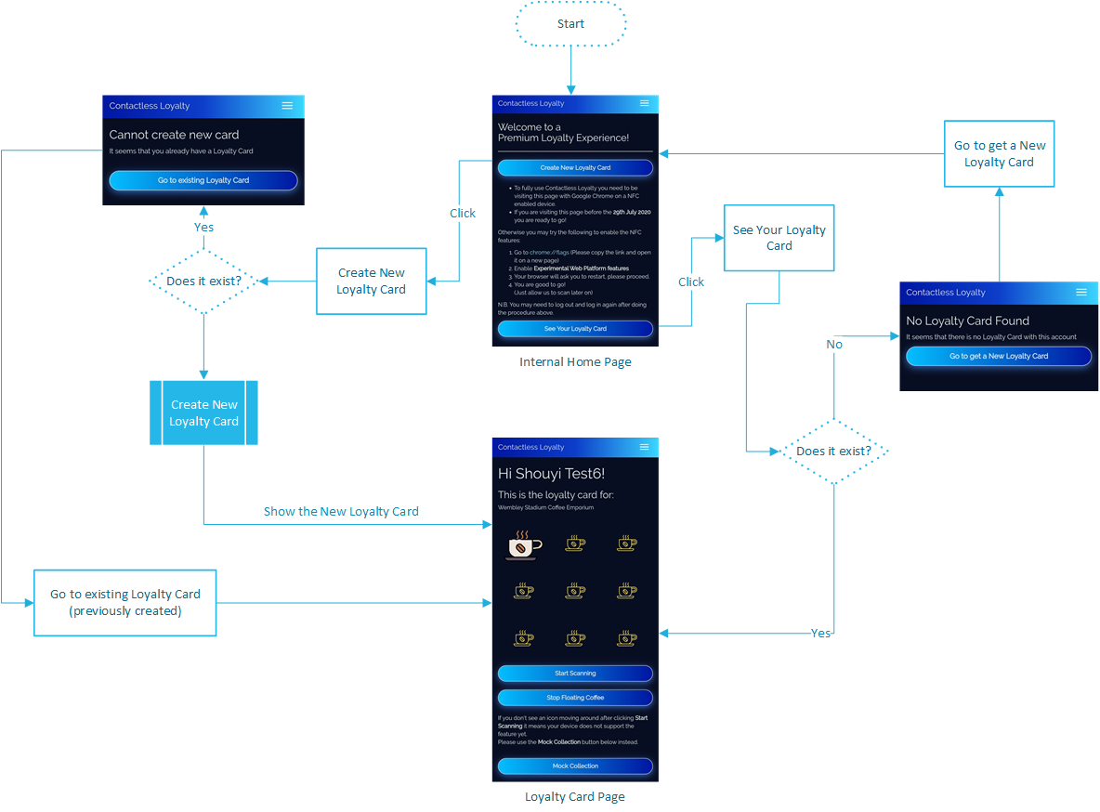

Figure . Internal Home Page with Flowchart and Wireframes

### Loyalty Card Page

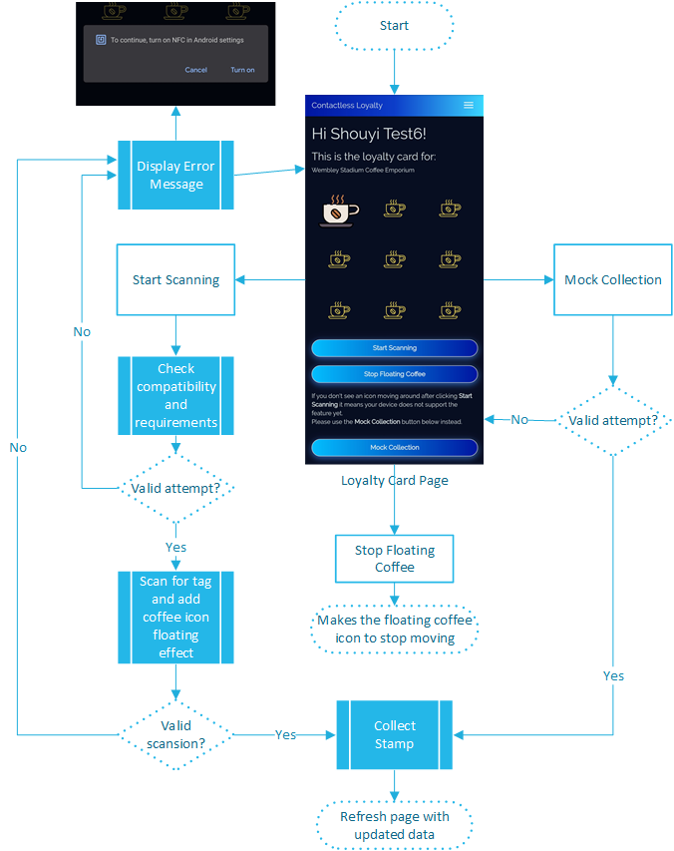

Figure . Loyalty Card Page with Flowchart and Wireframes

### Reward Available Flowchart and Voucher Sent Page

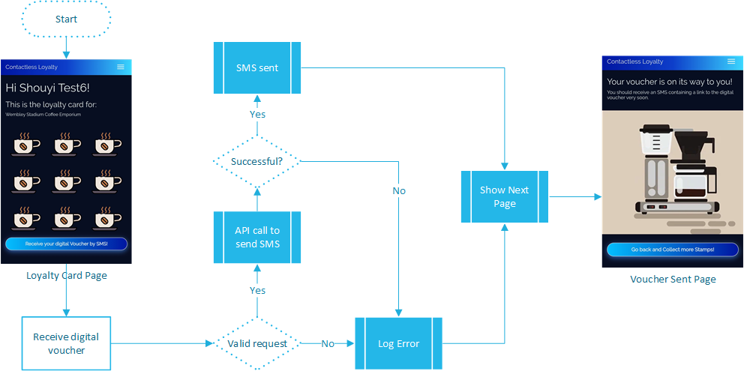

Figure . Collection Page Flowchart with Wireframes

### Menu Options and Account Management

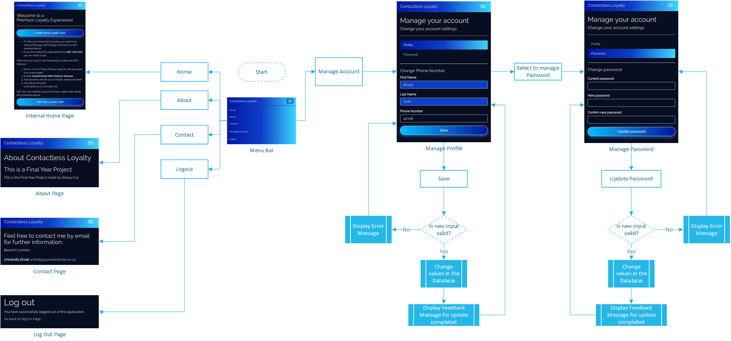

Figure . Menu options and Manage Account Page Flowchart with Wireframes

# Tools and implementation

## Tools

Programming languages, libraries, framework with choice justification. Razor pages

### Visual Studio MVC

### Git

### StyleCop

### Chrome Developer Tools

### Entity Framework Core

<https://docs.microsoft.com/en-us/ef/core/miscellaneous/cli/powershell>

### Adobe Illustrator

### Visual Studio

## Implementation - Loyalty Scheme system

### Digital card visualisation

### Web API

### Collecting the stamp

### Creating the stamp

## Deployment

### Web Application setup

### Database setup

# Testing

# Conclusions and Reflections

# Reference and Bibliography

Appendix 1